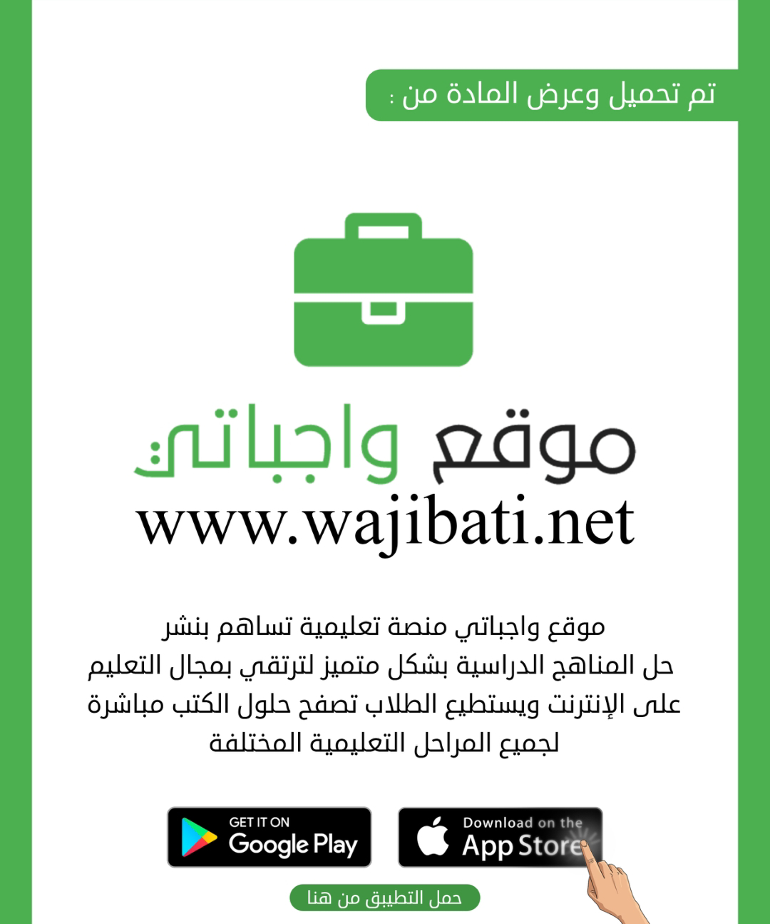

# نتيجة بحث الصور عن شعار الوزارة شفاف

Super Goal 3 - English Language

**Third Intermediate Grade**

Third Term Final Exam 1445-2024

**First Round** | Time: 1.5 hour

Kingdom of Saudi Arabia

Ministry of Education

………. Education Directorate

……………Intermediate School

**المراجع**

**checker**

**أ /..........**

**الدرجة كتابه**

**Written**

**المجموع**

**Total / 30**

**المصحح**

**corrector**

**أ / راشد السلمي**

**Q16**

**Q26**

**Q37**

**Q4**

**4**

**Q57**

اسم الطالب

رقم الجلوس

Composition

**اللهّم لا سَهلَ إلا ما جعلتُه سَهلاً فإنكَ تَجعَلُ الحزنَ إذا شِئتَ سَهلاَ " "**

**Write about the kinds of people you like to be friends with. What characteristics do they have?**

Guide words:

**( interests – supportive - spending time – responsible – grow up – personality – friendship - respect )**

..................................................................................................................................................................................................................

..................................................................................................................................................................................................................

..................................................................................................................................................................................................................

..................................................................................................................................................................................................................

..................................................................................................................................................................................................................

..................................................................................................................................................................................................................

..................................................................................................................................................................................................................

..................................................................................................................................................................................................................

..................................................................................................................................................................................................................

..................................................................................................................................................................................................................

**6**

**اقلب الصفحة**



Comprehension

**6**

* **Read the following passage and answer the questions below:**

**Visit Italy**

Italy is the fifth most visited country in the world. Why? Because there is so much to see and do there! People visit Italy to see its fantastic architecture, to explore ancient ruins and learn about their history, and–of course–to eat wonderful Italian food!

Visit Rome

See the Coliseum. This huge arena was built about 72 C.E., and it’s still standing! Many people think it is the greatest work of Roman architecture ever built. Explore the Coliseum and learn what the ancient Romans used this enormous building for.

Visit Florence

This is wonderful city for exploring museums and looking at beautiful architecture.

Visit Venice

Venice is one of the most beautiful cities in the world. A popular thing to do in this city is to eat a delicious Italian dinner and then take a gondola boat through the canals.

Visit Pompeii

Explore the ancient city of Pompeii. Walk through the ruins and experience history. Discover what life was like for Romans in 79. C.E. when the city was buried by the eruption of the volcano Mount Vesuvius.

**A. Choose the correct answer:**

1. _____ is one of the most beautiful cities in the world.

**a**. Rome  **b**. Florence **c**. Venice **d.** Pompeii

1. In Pompeii, you can learn about life in ____..

**a**. 79 c.e. **b** 72 c.e. **c** 790 c.e. **d.** the 1700s

1. A gondola is a ________.

**a**. car  **b**. boat **c**. bicycle **d.** helicopter

**B. Write (T) for True or (F) for False:**

|  |  |
| --- | --- |
| **4.**  Italy is the third most popular country to visit in the world |  |
| **5.** Florence is home to many museums |  |
| **6.** A popular thing to do in Florence is to ride in a gondola |  |

**اقلب الصفحة**



**7**

Grammar

* **Choose the correct answer**

1. We were sitting in the café when a thief _____ my bag!

**a**. steal **b**. stole  **c**. was stealing **d.** stolen

1. Jack was talking on the phone _____ he was driving.

**a**. that **b**. while **c**. where **d.** which

1. She was cooking dinner _____ I arrived .
2. when **b**. while **c**. where **d.** which
3. I _____ at the monument when someone called my name.
4. look **b**. looked  **c**. am looking  **d.** was looking
5. Have you ______ washed the clothes ?

**a**. already **b**. yet  **c**. just  **d.** already not

1. The salesperson was _____ pushy that I left the store without buying anything.
2. so **b**. such **c**. much **d.** so much
3. He enjoys _____ in the high-tech computer field.
4. work **b**. worked  **c**. working **d.** to work
5. He has ________books that he can hardly carry them .
6. so much **b**. much **c**. so many **d.** that many
7. **Bart:** Do you prefer to walk or take the bus? **Bob:**_________________.

**a**. I rather walk **b**. I had rather walk  **c**. I did rather walk **d.** I would rather walk

1. I wish I _____ so much homework.
2. had **b**. hadn’t  **c**. didn’t have **d.** not have
3. If fewer people _____ their cars, there wouldn’t be so much traffic.
4. drove **b**. will drive  **c**. would drive **d.** drive
5. I wish I _____ what to do. Can you give me some advice?
6. will know **b**. would know **c**. know **d.** knew
7. I miss ____________________ time with my friends.

**a**. to spend **b**. spends  **c**. spend **d.** spending

1. I’m sorry. I didn’t expect ____________________ out so late.
2. is be **b**. being  **c**. to be **d.** be

Orthography

**4**

* **Choose the correct letters :**

1. The people who live in the city are always in a hur….y ( c – r – k )
2. The watches that the man was s….lling were fakes . ( e – h – n )
3. I hate this program. I’m going to turn it of…. ( c – f – k )
4. Have you taken the garbage o…t yet? ( e – h – u )
5. If I don’t wear cool clothes, I won’t fi….. in ( t – f – k )
6. If I study for this test, I’ll pas…. ( e – h – s )
7. Remember to stand in li….e ! ( t – n – k )
8. Try not to spread dust and mud in the ho…se ( u – h – s )

**اقلب الصفحة**



**7**

Vocabulary

* **Choose the correct answer:**

1. **Max:** Why are the police talking to Jerry? **Jason:** He saw a man who tried to __________ a bag

**a**. steal **b**. fake  **c**. pretend **d.** in a hurry

1. That diamond is not real. It is ____________________.

**a**. thief  **b**. give direction  **c**. fake **d.** steal

1. Some people are always ____________________. They don’t have time to talk and relax.

**a**. pretend **b**. in a hurry  **c**. steal  **d.** give direction

1. You use a toothbrush and _______________to brush your teeth.

**a**. toothpaste **b**. hair dryer  **c**. shampoo **d.** scissors

1. You use ____________________ to cut paper.

**a**. dishwashing liquid **b**. scissors  **c**. hair dryer **d.** mirror

1. You use a ____________________ to dry your hair when it is wet.

**a**. shampoo **b**. toothpaste  **c**. hairbrush  **d.** hair dryer

1. If you drive too fast, you’ll get a____________.

**a**. ticket **b**. conservationist  **c**. benefit **d.** scenic

1. Donna tries too hard to ________. She always does what other people are doing.

**a**. cheat **b**. scenic  **c**. pollution **d.** fit in

1. One __________ to being a professional sports player is that they make a lot of money.

**a**. generate **b**. pollution  **c**. benefit  **d.** conservationist

1. Americans usually introduce themselves with their ________________ name.

**a**. Second **b**. last  **c**. middle  **d.** first

1. Ali thanks his friend the_______ for his hospitality .

**a**. late **b**. host  **c**. Rush  **d.** Break

* **Write the correct word under the picture.**

Tennis player – Taxi – Dishes

**صورة تحتوي على مركبة, سيارة طرق وعرة, عجلة, المواصلات

تم إنشاء الوصف تلقائياً**صورة تحتوي على نص

تم إنشاء الوصف تلقائياً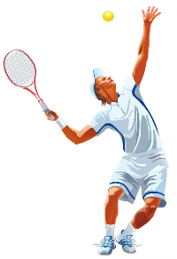

**12.**

**14.**

**13.**

…………………..……….

…………………..……….

…………………..……….

**انتهت الأسئلة .. ..**

**وبالله التوفيق والنجاح ..**

**الأستاذ / راشد السلمي**

**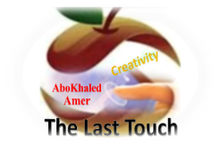****المملكة العربية السعودية**

**Kingdom of Saudi Arabia**

**Ministry of Education**

**------- Educational Directorate**

**------- Future Educational Schools**

**3rd grade intermediate 2022**

**3rd Term – Final Exam**

**وزارة التعليم**

**الإدارة العامة للتعليم بن**

**مدارس م ن التعليمية**

**الصف الثالث المتوسط**

**الاختبار النهائي للفصل الدراسي الثالث1445**

|  |  |  |  |  |  |  |  |
| --- | --- | --- | --- | --- | --- | --- | --- |
| **Total**  **written** | **5 spelling** | **4 Vocabulary** | **3 Grammar** | **2 Comprehension** | | **1 Composition** | **Q. NO.** |
|  |  |  |  |  | |  | **Mark Given** |
| **30** | **4** | **7** | **7** | **6** | | **6** | **Mark** |
|  | | | **Reviser** | |  | | **Corrector** |
|  | |

**زمن الاختبار: ساعتان**

**اسم الطالب: ------------------------------------ رقم الجلوس: ------------- الصف الثالث المتوسط**

**6**

1) **Composition**

**1- Write a paragraph about “Bad Behaviors"**

**Give your opinion about it. Use the questions below to guide you:**

1.What is the worst impolite behavior that you don’t like? 2.How does it affect others?

3.Do you think we should change this bad habit? why?

…………………………………………

………………………………………………………………………………………………………………………………………………………………………………………………………………………………………………………………………………………………………………………………………………………………………………………………………………………………………………………………………………………………………………………………………………………………………………………………………………………………….

**6**

**2) Comprehension**

**2- Read the following passage then answer the questions:**

**The Kingdom of Saudi Arabia has a rich culture shaped by the diversity of its people, which has formed the basis of the cultural identity of the Kingdom. With over 34 million inhabitants, the Kingdom has 13 regions all united by the Arabic language, but each with a unique: dialect, traditions, heritage, and culinary identity. The Kingdom has three official yearly celebrations; two Islamic celebrations, Eid al-Fitr and Eid al-Adha, and Saudi National Day, which is celebrated on September 23rd.** **Many poor Saudi families rely on handouts from private citizens. Muslims are expected to give a portion of their annual income to charity, The people of Saudi Arabia embrace many social values influenced by their Islamic values which preserve the Kingdom’s ancient customs and traditions. These values include generosity, courage, hospitality, and maintaining strong family relationships.**

**A- Put ( T ) or ( F ):**

**1. The Kingdom has five official yearly celebrations. ( )**

**2. Muslims are expected to give Zakat for charity. ( )**

**B- Choose the correct answer:**

**1. The main idea of the passage is -------**

a. Culture of Saudi Arabia b. Culture of Egypt c. Culture of India

**2. In line 1 (rich) is the opposite of -------**

a. funny b. cold c. brave d. poor

**3. In line 9 (their) refers to -------**

a. kingdoms b. relationships c. traditions d. people

**4. The family have dinner at ------ p.m.**

a. Spanish b. English c. Arabic d. Chinese

**3) Grammar**

**7**

**A: Choose the correct answer:**

**1. He tries to avoid ………………… him on the street.**

a. sees b. seeing c. to see d. see

**2. He is a generous man. Do you know …………………?**

a. had escaped b. escape c. escaping d. escapes

**3. Have you already …………………... to John?**

a. writing b. wrote c. written d. to write

**4. If my husband ……………. , he burns the food.**

a. cooked b. cooks c. cook d. cooking

**5. Julie is ………………. good writer.**

a. such an b. such c. so d. such a

**6. I live in a house, ………………. is very big.**

a. when b. who c. which d. why

**7. She decided ………………………… at home.**

a. stays b. stayed c. to stay d. staying

**4) vocabulary:**

**7**

**Pairing Questions:**

|  |  |  |
| --- | --- | --- |
| **1. Bill failed his exam.** |  | **a. to hit or knock against it.** |
| **2. The workers began to protest.** |  | **b. to show great disagreement** |
| **3. He bumped his head against the shelf.** |  | **c. to put a plan or an idea.** |
| **4. The children rushed down the stairs.** |  | **d. the opposite of pass.** |
| **5. The mother was patient with her son.** |  | **e. to stay calm.** |
| **6. I suggest that you call the store.** |  | **f. to move very quickly.** |

**Choose the correct Answer:**

**1. The ……………… helped her with her luggage.**

a. painter b. porter c. writer d. lawyer

**2. Did you remember to …………………. the taxi driver?**

a. read b. buy c. tip d. make

**3. The …………………. grows potatoes in this field.**

a. farmer b. policeman c. student d. doctor

**4. Air …………………..is a serious global problem.**

a. graduation b. conservationist c. energy d. pollution

**5. Don't …………… water at your brother.**

a. feed b. splash c. start d. wear

**6. The twins often …………………… each other's clothes.**

a. sell b. drive c. borrow d. cut

**7. It is a good …………………… to fly with.**

a. airline b. flyer c. gate d. mask

**8. She was the most helpful and ……………………. person to work with.**

a. selfish b. unkind c. stupid d. generous

**5) Orthography**:

**4**

**Choose the correct letters:**

**1. Tom is ambitious and o__timistic.** ( o – a – p – u )

**2. Hang on while I g__ab a cup of coffee.** ( c – r – t – m )

**3. He is the edit__r of a daily paper.** ( o – f – i – k )

**4. He was h__rdworking and very intelligent.** ( f – a – n – u )

**5. Will you please stop using my hairbr__sh?** ( i – d – k – u )

**6. All my socks are dir__y.** ( v – f – t – k )

**7. A sponge absorbs liqui__s.** ( f – d – o – u )

**8. He is always pol__te to everyone.** ( s – t – e – i )

**End of Questions**

**Best of Luck https://t.me/abokhaledamer**

**المملكة العربيةالسعودية الصف: ثالث متوسط**

**وزارة التعليم مادة : اللغة الإنجليزية**

**المتوسطة الزمن: ساعة ونصف**

**أسئلة اختبار الفصل الدراسي الثالث للعام 1445هـ**

**عدد الصفحات: 3 عدد الأسئلة :5**

++++++++++++++++++++++++++++++++++++++++++++++++++++++++

|  |  |  |
| --- | --- | --- |
|  |  |  |
| **I-Composition:** |  | **6** |

‘’ **Every culture’s history is essential.** “

Write about Cultural Differences. Use the following words: ( respect , language, religion, lifestyle, characteristic, peace and group )

**__________________________________________________________________**

**__________________________________________________________________**

**__________________________________________________________________**

**__________________________________________________________________**

**__________________________________________________________________**

**__________________________________________________________________**

**__________________________________________________________________**

**__________________________________________________________________**

**__________________________________________________________________**

**__________________________________________________________________**

**__________________________________________________________________**

**__________________________________________________________________**

**__________________________________________________________________**

**_______________________________________________________**

6

**II-Comprehension:**

6

**Read the passage and answer the questions below:**

Khaled is seventeen years old. He lives in Jeddah. His best friend is Omar. He is sixteen years old. He lives in Abha. Last month Khaled went to Abha to see his friend Omar. Khaled and Omar went to their favorite campsite in the mountains. It is near the top of Mount Souda in the Alakas village. The view was amazing in the evening. The sky turned bright orange and pink as the sun set behind the hills. They could see the valleys and rivers from the Ashran Dam at the top of the mountain. Khaled and Omar did very exciting things. First of all, there was a small pond near the campsite, so Khaled swam a lot when he got hot. Also, Omar like hiking, so **he** went on hiking every morning because there were good hiking trails. they had lots of fresh air during their stay on the mountain. There was a small village near our campsite. In the afternoons Khaled and Omar walked there so they had fresh food every day. They had delicious Kabsah. In the evenings they set a campfire and told stories to each other around the fire. They enjoyed a lot and had a wonderful time during their trip.

|  |  |  |  |  |
| --- | --- | --- | --- | --- |
| **Multiple Choice ( 1- 35 )** | | | | |
| **Comprehension (1-4)** | | | | |
| **A*Choose the correct answer :** | | | | |
| **1**- The **main idea** of the passage is … ……………. | | | | |
| d. The family | | c- The moon is great | b- The camping trip | a- Types of food |
| **2**-In line 4 (bad) is the opposite of.. | | | | |
| d. amazing | | c- dry | b- hot | a- dark |
| 3-In line 7 (**he**) refers to…. | | | | |
| d- Faisal | | c- Yahya | b- Khaled | a-Omar |
| **4**- Khaled is ………………….. years old. | | | | |
| d. 16 | | c- 17 | b- 15 | a- 18 |
| **F**alse**\T**rue | **B*Put ( T √) or ( F x ) (1-2)** | | | |
|  | 1- Khaled swam a lot when he got cold. | | | |
|  | 2- They had fresh food every day. | | | |

|  |  |  |
| --- | --- | --- |
| **III-Grammar:/Multiple Choice: ( 5 to 11 )** |  |  |
| **Choose the correct words:** |  | **7** |

|  |  |  |  |
| --- | --- | --- | --- |
| **5**-You were reading when I ……………………. in. | | | |
| d- walking | c- to walk | b- walks | a- walked |
| **6**- I’d rather …………. to the cinema on Tuesday. | | | |
| d-go | c-goes | b- went | 1. going |
| **7**- I myself love to have …………………. nice job. | | | |
| d-such an | c- so many | 1. such a | 1. so much |
| **8**- My house, ………………………… was quite small, was in Riyadh. | | | |
| d- when | c-who | 1. where | 1. which |
| **9**- If people ……………… too much, they get fat. | | | |
| d- eating | c- eat | b- eats | 1. ate |
| **10**- I have finished ………………………. | | | |
| d- work | c- works | 1. working | 1. worked |
| **11**- I haven't …………………. a decision yet. | | | |
| d- made | c-makes | b-making | 1. to make |

**77**76

|  |
| --- |
| **Vocabulary: ( 1 to 6 )** |
| **Pairing Question:** |

|  |  |  |  |  |
| --- | --- | --- | --- | --- |
| 1 | I gave a **fake** name. |  | A | a substance that you use to wash your hair |
| 2 | This **shampoo** smells fruity. |  | B | not real |
| 3 | He's very **punctual**. |  | C | to look after |
| 4 | She took **care** of the children. |  | D | the antonym of hardworking |
| 5 | He is a very **lazy** boy. |  | E | the synonym of on time |
| 6 | May I **borrow** your pen? |  | F | the antonym of clean |
|  | | | G | to take or use with the promise to return |

|  |
| --- |
| **IV-Vocabulary:/Multiple Choice: ( 12 to 19 )** |
| **Choose the correct words:** |

|  |  |  |  |
| --- | --- | --- | --- |
| **12-** Our information comes from a ………….. source. | | | |
| d- silly | c- typical | b- reliable | a- talkative |
| **13**- The ………………… is wanted by the police. | | | |
| d- officer | c- firefighter | b- guard | a- thief |
| **14**- Water was ……………………. from a hole in the roof. | | | |
| d- splashing | c- minding | b- suggesting | a- feeding |
| **15**. When ice melts, it becomes ………………... | | | |
| d- gas | c- plasma | b- liquid | a- solid |
| **16**- …………………….. is damaging our earth. | | | |
| d- Ecosystem | c- Pollution | b- Environment | a- Conservationist |
| **17**- I am going to …………………. math and science next year. | | | |
| d- relax | c- work | b- listen | a- study |
| **18**- Say "sorry" if you ………………….. into someone. | | | |
| d- comment | c- bump | b- allow | a- spear |
| **19**- The horses make ………….. as they run. | | | |
| d- dust | c- wind | 1. rock | a- leaf |

**4**76

|  |
| --- |
| **V-Orthography (Spelling): ( 20 to 35 )** |

|  |  |  |  |  |  |  |  |  |  |  |  |  |
| --- | --- | --- | --- | --- | --- | --- | --- | --- | --- | --- | --- | --- |
| 20 | A ki__d word is never lost. | | | | | | | 28 | There is no cause for com__laint. | | | |
| a. n | b. t | | c. z | | d.f | | a. h | b. z | c. f | d. p |
| 21 | New Abha is famous as a summer reso__t. | | | | | | | 29 | It is pol__te that she accepts his invitation. | | | |
| a. v | | b. s | | c. r | | d. j | a. e | b. i | c. u | d. a |
| 22 | Each country has its own custo__s. | | | | | | | 30 | I had the po__ter carry my suitcase. | | | |
| a. f | | b. m | | c. z | | d. q | a. d | b. x | c. h | d. r |
| 23 | The edit__r cut my article. | | | | | | | 31 | Do not adj__st your set | | | |
| a. e | | b. i | | c. o | | d. a | a. i | b. u | c. e | d. a |
| 24 | It will be to your b__nefit to arrive early. | | | | | | | 32 | He applied for the school__rship. | | | |
| a. u | | b. e | | c. a | | d. e | a. i | b. e | c. a | d. o |
| 25 | We can fin__sh it later. | | | | | | | 33 | I r__cognize you now. | | | |
| a. i | | b. o | | c. u | | d. a | a. e | b. a | c. o | d. u |
| 26 | I can't s__and his attitude. | | | | | | | 34 | He looked in a mirr__r. | | | |
| a. b | | b. g | | c. t | | d. r | a. o | b. i | c. e | d. u |
| 27 | Jack is a c__ever student. | | | | | | | 35 | Tom always tries to a__oid trouble. | | | |
| a. l | | b. k | | c. h | | d. f | a. t | b. v | c. s | d. n |

**End of Questions**

**Best OF Luck !**

**Tr.**